Clumsy Bat Level Descriptions

|  |  |
| --- | --- |
| Normal Levels | 14 |
| Shrines | 2 |
| Bosses | 5 |

Level Map:

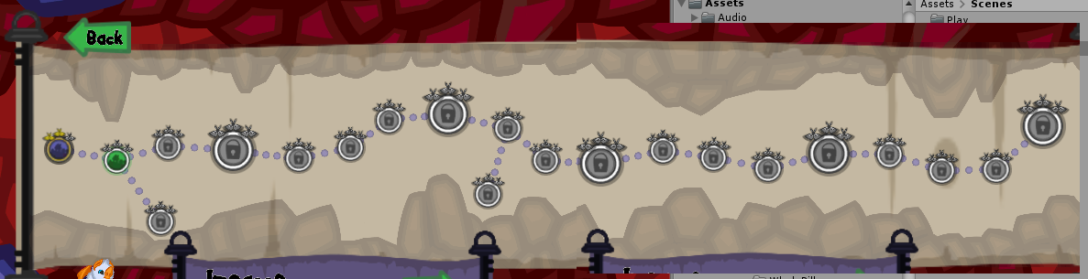

Large icons are bosses (a variation of Rockbreath)

Icons on the main path are normal levels

Icons off the main path are shrines, where abilities are obtained. These are accessed via a secret exit in the attached level.

Normal Levels

|  |  |  |  |
| --- | --- | --- | --- |
| Level | Name | Description | Target Score |
| 1 |  | Introduce Nomee, and moths as collectibles | 4800 |
| 2 |  | Introduce Spikes (first obstacle), and a secret exit to shrine*** | 8500 |
| 3 |  |  | 7200 |
| 4 |  |  | 5100 |
| 5 |  |  | 7700 |
| 6 |  |  | 5100 |
| 7 |  |  | 4800 |
| 8 |  |  | 5200 |
| 9 |  |  | 5200 |
| 10 |  |  | 5200 |
| 11 |  |  | 5200 |

*** suggest moving this to a later level